Rhode Island Department of Business Regulation,
Office of Cannabis Regulation

Renewal Application for Medical Marijuana
Cultivator License

Publication Release Date: August 10, 2021

Questions about the Renewal Application and renewal process should be submitted to the Department by email to DBR.MMPcompliance@dbr.ri.gov.

APPLICATION INFORMATION SHEET*
1 | COMPANY NAME  (legal name, and any d/b/a name(s), if applicable) | Company Name
2 | STREET ADDRESS | Street Address
3 | CITY, STATE, ZIP | City, State, Zip

4 | STREET ADDRESS OF LICENSED PREMISES | Street Address
5 | CITY, STATE, ZIP | City, State, Zip
6 | PLAT/LOT # OF LICENSED PREMISES
7A | OWNER OF LICENSED PREMISES | Are the premises owned or leased by the Applicant? (check one)  ☐ Owned  ☐ Leased  If the licensed premises are leased, please complete the below:  Full Name of Owner/Lessor:  Owner/Lessor Contact Person:  Owner/Lessor’s Address:  If the premises are leased by the Applicant, please provide a copy of the Lease, which must include a provision, or attached letter signed by the Lessor, authorizing the Applicant’s use of the premises for medical marijuana cultivation.
7B | License Class  (select one): | ☐ Micro-license (Annual license fee: $5,000.00)  ☐ Class A (Annual license fee: $20,000.00)  ☐ Class B (Annual license fee: $35,000.00)
7C | License Number: | MMP CV  (this is the number referenced on the License issued by the Department)

8 | TELEPHONE NUMBER
 | AREA CODE  Area Code | NUMBER:  Number | EXTENSION:  Extension

9 | FAX NUMBER
 | AREA CODE  Area Code | NUMBER:  Number | EXTENSION:  Extension

10 | TOLL FREE NUMBER
 | AREA CODE  Area Code | NUMBER:  Number | EXTENSION:  Extension

11 | Contact Person for providing information, notices, signing documents, or ensuring actions are taken per the Act and Regulations
 | Name: Name
 | Title: Title
 | Address: Address
 | Email Address: Email Address

12 | TELEPHONE NUMBER AND FAX FOR CONTACT PERSON
 | AREA CODE  Area Code | TELEPHONE NUMBER:  Number | EXTENSION:  Extension
 | AREA CODE  Area Code | FAX NUMBER:  Number

13 | CONTACT PERSON SIGNATURE
 | SIGNATURE: | DATE:  Click here to enter a date.

TABLE OF CONTENTS
SECTION | SECTION TITLE | PAGE NUMBER
 | Introduction | 4
 | How to Renew Your License | 5
 | General Instructions | 6
 | Renewal Application Delivery | 6
Form 1 | Affirmation Section | 7
Form 2 | Disclosure of Owners, Investors, and Other Interest Holders | 10
Form 3 | Business License Identification Form | 15
Form 5 | Interest Holders Certification Statement | 16
Form 6 | Mandatory Questions | 18

Introduction
Pursuant to The Edward O. Hawkins and Thomas C. Slater Medical Marijuana Act, Rhode Island General Laws § 21-28.6-1 et seq (the “Act”), the Department of Business Regulation is responsible for licensing and regulation of cultivators of medical marijuana. Licensed cultivators may sell medical marijuana and medical marijuana products to registered compassion centers in accordance with the Act and Rules and Regulations Related to the Medical Marijuana Program Administered by the Department of Business Regulation, 230-RICR-80-05-1 (the “Regulations”). Please thoroughly review the Regulations which can be found on the Department’s website accessible at the following link: http://www.dbr.ri.gov /.

How to Renew Your License
A Licensee must submit a complete Renewal Application package no later than 3:00 p.m. on the the business day next preceding the expiration date set forth in its license. The Renewal Application package must include the following:
- A signed, hard copy of the Licensee’s completed Renewal Application with all completed Forms and any supporting documents,
- The applicable Annual License Fee as described in Question 7A on page 2 hereof, payable to the General Treasurer, State of Rhode Island, in the form of a cashier's check or money order only, and
- A list prepared by the Licensee of all “licensed cultivator cardholders” associated with the Licensee as described in Section 1.6 of the Regulations.
- A list prepared by the Licensee of all consultants currently employed or utilized by the licensee, or who have been employed utilized or by the licensee within the last year. Failure to disclose consultants or advising third parties will result in a denial of the renewal application and/or revocation or suspension of the cultivation license.
- A current copy of the Licensee’s visitor log documenting all visitations for the previous term of the license.
- Proof of compliance with local zoning laws. This may include a copy of a valid certificate of occupancy, special use permit, and/or letter from the local zoning office.
- A list of all manufacturing processes currently used by the licensee. (If applicable)
- A document showing the licensee’s current inventory of medical marijuana. This shall include the number of seedlings/clones, immature plants, mature plants, and the weight and/or volume of marijuana flower, extracts, edibles, and all other applicable marijuana products.
- Current letter(s) of good standing from the Rhode Island Department of Taxation documenting that the licensee has fulfilled all tax obligations and are not in arrears. These letters may be submitted up to sixty (60) days after the submission of items 1 through 8 above.
- An electronic or digital copy of items 1 through 8 submitted via flash drive or emailed to mailto:DBR.MMPCompliance@dbr.ri.gov
The Application is only considered complete if all of these components are submitted. The Licensee is responsible for delivery of all of the Renewal Application materials to the Department on or before the renewal application deadline indicated above.

Renewal of your medical marijuana cultivator license is subject to an annual inspection by the Department of Business Regulation. Following receipt of your Renewal Application, the Department will contact you to schedule your annual inspection.

General Instructions

Read each question carefully. Answer each question completely. Do not leave blank spaces. If a question does not apply, write “Does Not Apply” or “N/A.” If the correct answer to a particular question is “None,” write “None.” If a question has an asterisk (*), it is mandatory and must be completed. Answering a mandatory question with “Does Not Apply” or “N/A” is insufficient. Failure to timely submit a Renewal Application with all of the mandatory questions completed may result in the expiration and/or revocation of your license.

- Signatures on the hard copy Renewal Application must be in handwriting, unless otherwise stated by the Department, by the individual providing the information. Do not misstate or omit any material fact(s).
- All Supporting Documents, such as business formation papers and appendices, as well as the Renewal Application forms that comprise a Renewal Application package, as listed above, must be submitted at the time of filing this Renewal Application. Further, the Licensee is under a continuing duty to promptly notify the Department of Business Regulation if there is a change in the information provided to the Department.
Renewal Application Delivery

- It is the Licensee’s responsibility to allow sufficient time to address potential delays.
- Sole responsibility rests with the Licensee to ensure that their Renewal Application is received by Department of Business Regulation on or before the renewal application deadline.
- If delivering in-person, please leave Application in the locked mailbox at the top of the lobby stairs..

Office of Cannabis Regulation Delivery Address:

Office of Cannabis Regulation
560 Jefferson Blvd Ste. 204,
Warwick, RI 02886
401-462-9500

FORM 1*
Affirmation Section
The Licensee understands the following:
 | Yes | No
- The Department of Business Regulation may deny a Renewal that contains a misstatement, omission, misrepresentation, or untruth. | ☐ | ☐
- The Renewal shall be complete in every material detail. | ☐ | ☐
- In regards to the location of the licensed premises, the
Licensee reaffirms its commitment to the following:
- The premises and operations of a Licensee continue to  conform to local zoning requirements. | ☐ | ☐
- The Cultivator License is conspicuously displayed  at the licensed premises. | ☐ | ☐
- In regards to manufacturing, the licensee reaffirms its commitment to not have or engage in any form of manufacturing that uses a heat source or flammable/combustible material without prior approval of the State Fire Marshall and/or the local fire department. | ☐ | ☐
- The licensee reaffirms its commitment to not using any compressed, flammable gas as a solvent in any solvent extraction process, manufacturing or for any other purpose. | ☐ | ☐
- The licensee reaffirms its commitment to not supplying medical marijuana to anyone other than a registered compassion center in accordance with the Act and the Regulations. | ☐ | ☐
- The licensee reaffirms its commitment to comply with the requirements and to be subject to the limitations set forth in the Act and the Regulations and understands that the licensee is limited to possessing marijuana only as permitted in the Act and the Regulations. | ☐ | ☐
- The licensee reaffirms that it will comply with the Regulation which provides that a licensed cultivator may not have any material financial interest or control in another licensed cultivator, in a compassion center or a licensed cooperative cultivation or in a Rhode Island Department of Health approved third party testing provider and vice versa. | ☐ | ☐
The undersigned attests that the Licensee organization understands and will adhere to the all requirements of the Act and the Regulations, including but not limited to those listed above, and that they have the authority to bind the Licensee organization to all requirements.

Click here to enter a date.
Authorized Signatory Date

Printed Name
Printed Name

Notice Pertaining to Testing:
Compassion centers and licensed cultivators will be required to comply with the DOH Testing Regulations (as defined in the Regulations) to be hereafter promulgated by the Rhode Island Department of Health. The DOH Testing Regulations may require compassion centers and/or licensed cultivators to pay the costs associated with testing their products. I understand that medical marijuana testing will be required under the DOH Regulations and that this testing may come at an additional expense.

Click here to enter a date.
Authorized Signatory Date

Printed Name
Printed Name

Notice Pertaining to the Use of an Inventory Tracking System:
Upon direction by the Department of Business Regulation, all licensed cultivators shall be required to use the state approved Medical Marijuana Program Tracking System (as defined and described in the Regulations). Licensed cultivators may be required to pay costs associated with use of the Medical Marijuana Program Tracking System, which may be assessed on an annual, monthly, per use, or per volume basis and payable to the state or to its approved vendor.

I understand that I will be required to use the state approved Medical Marijuana Program Tracking System in accordance with the Regulations and that access to and use of this system may come at an additional expense.

Click here to enter a date.
Authorized Signatory Date

Printed Name
Printed Name

Notice Pertaining to Criminal Background Checks

All officers, directors, managers/members, employees, and agents of the Licensee must apply for a registry identification card and all officers, directors, and managers/members must submit to a national criminal background check. Such individuals may be hired, appointed, or retained prior to receiving a registry identification card, but may not begin engagement in medical marijuana cultivation, storage, processing, packaging, manufacturing, transport, or other medical marijuana activities requiring a licensed cultivator license pursuant to the Edward O. Hawkins and Thomas C. Slater Medical Marijuana Act until receipt of the card. DBR may also require that any other persons who have authority to make decisions concerning the operation of, exercise control over, or are otherwise involved in the management of, and/or have an ownership interest in the cultivator Licensee or proposed cultivator activities (“Interest Holders”) apply for a registry identification card and submit to a national background check.

The undersigned attests that the Licensee organization understands that all relevant parties must apply for a registry identification card and pass a criminal background check in accordance with the Act and the Regulations before engaging in cultivator activities.

Click here to enter a date.
Authorized Signatory Date

Printed Name
Printed Name

FORM 2*
Disclosure of Owners and Other Interest Holders

Name of Applicant/Licensee: _______________________________________

Part I: Owners and Other Interest Holders
List (A.) all persons and/or entities with any ownership interest with respect to the applicant/licensee, and (B.) all officers, directors, members, managers or agents of the applicant/licensee, and (C.) all persons or entities with managing or operational control with respect to the applicant/licensee, its operations, the license and/or licensed facilities whether they have an ownership interest or not, and (D.) all investors or other persons or entities with any financial interest whether they have ownership interest or not, and (E.) all persons or entities that hold interest(s) arising under shared management companies, management agreements, or other agreements that afford third-party management or operational control with respect to the applicant/licensee, its operations, the license and/or the licensed facilities (all persons and entities described in (A)-(E) being hereinafter individually referred to as an “Interest Holder” and collectively referred to as “Interest Holders”).

To the extent that any Interest Holder is an entity (corporation, partnership, LLC, etc.), list all Interest Holders in that entity until all such Interest Holders are identified and disclosed down to the individual person level. Attach a separate sheet(s) if necessary.

- LIST ALL PERSONS AND/OR ENTITIES WITH ANY OWNERSHIP INTEREST IN THE APPLICANT/LICENSEE (including corporation stockholders; LLC members; and partners if a partnership; this includes parent companies if the applicant/licensee is a subsidiary of another entity).

To the extent that any Interest Holder is an entity (corporation, partnership, LLC, etc.), list all Interest Holders in that entity until all such Interest Holders are identified and disclosed down to the individual person level.
Name | Title |  |  | SSN/FEIN |  | DOB |  | Key Staff App submitted?  ☐Yes ☐No
Address (residence if an individual) | City |  | State |  | ZIP | Phone Number  ( )
Business Associated with (Applicant, parent business or sub-entity) |  | Own. % Business Associated with |  |  |  |  | Effective Own. % in Applicant
Name | Title |  |  | SSN/FEIN |  | DOB |  | Key Staff App submitted?  ☐Yes ☐No
Address (residence if an individual) | City |  | State |  | ZIP | Phone Number  ( )
Business Associated with (Applicant, parent business or sub-entity) |  | Own. % Business Associated with |  |  |  |  | Effective Own. % in Applicant
Name | Title |  |  | SSN/FEIN |  | DOB |  | Key Staff App submitted?  ☐Yes ☐No
Address (residence if an individual) | City |  | State |  | ZIP | Phone Number  ( )
Business Associated with (Applicant, parent business or sub-entity) |  | Own. % Business Associated with |  |  |  |  | Effective Own. % in Applicant
Name | Title |  |  | SSN/FEIN |  | DOB |  | Key Staff App submitted?  ☐Yes ☐No
Address (residence if an individual) | City |  | State |  | ZIP | Phone Number  ( )
Business Associated with (Applicant, parent business or sub-entity) |  | Own. % Business Associated with |  |  |  |  | Effective Own. % in Applicant
Name | Title |  |  | SSN/FEIN |  | DOB |  | Key Staff App submitted?  ☐Yes ☐No
Address (residence if an individual) | City |  | State |  | ZIP | Phone Number  ( )
Business Associated with (Applicant, parent business or sub-entity) |  | Own. % Business Associated with |  |  |  |  | Effective Own. % in Applicant
Name | Title |  |  | SSN/FEIN |  | DOB |  | Key Staff App submitted?  ☐Yes ☐No
Address (residence if an individual) | City |  | State |  | ZIP | Phone Number  ( )
Business Associated with (Applicant, parent business or sub-entity) |  | Own. % Business Associated with |  |  |  |  | Effective Own. % in Applicant
Name | Title |  |  | SSN/FEIN |  | DOB |  | Key Staff App submitted?  ☐Yes ☐No
Address (residence if an individual) | City |  | State |  | ZIP | Phone Number  ( )
Business Associated with (Applicant, parent business or sub-entity) |  | Own. % Business Associated with |  |  |  |  | Effective Own. % in Applicant
- LIST ALL OFFICERS, DIRECTORS, MANAGERS, MEMBERS OR AGENTS OF THE APPLICANT/LICENSEE AND ANY OTHER ENTITIES DESCRIBED IN SECTION A.

To the extent that any such Interest Holder is an entity (corporation, partnership, LLC, etc.), list all Interest Holders in that entity until all such Interest Holders are identified and disclosed down to the individual person level
Name | Title |  |  | SSN/FEIN |  | DOB |  | Key Staff App submitted?  ☐Yes ☐No
Address (residence if an individual) | City |  | State |  | ZIP | Phone Number  ( )
Business Associated with (Applicant, parent business or sub-entity) |  | Title (officer, director, manager, etc.)
Name | Title |  |  | SSN/FEIN |  | DOB |  | Key Staff App submitted?  ☐Yes ☐No
Address (residence if an individual) | City |  | State |  | ZIP | Phone Number  ( )
Business Associated with (Applicant, parent business or sub-entity) |  | Title (officer, director, manager, etc.)
Name | Title |  |  | SSN/FEIN |  | DOB |  | Key Staff App submitted?  ☐Yes ☐No
Address (residence if an individual) | City |  | State |  | ZIP | Phone Number  ( )
Business Associated with (Applicant, parent business or sub-entity) |  | Title (officer, director, manager, etc.)
Name | Title |  |  | SSN/FEIN |  | DOB |  | Key Staff App submitted?  ☐Yes ☐No
Address (residence if an individual) | City |  | State |  | ZIP | Phone Number  ( )
Business Associated with (Applicant, parent business or sub-entity) |  | Title (officer, director, manager, etc.)
Name | Title |  |  | SSN/FEIN |  | DOB |  | Key Staff App submitted?  ☐Yes ☐No
Address (residence if an individual) | City |  | State |  | ZIP | Phone Number  ( )
Business Associated with (Applicant, parent business or sub-entity) |  | Title (officer, director, manager, etc.)
Name | Title |  |  | SSN/FEIN |  | DOB |  | Key Staff App submitted?  ☐Yes ☐No
Address (residence if an individual) | City |  | State |  | ZIP | Phone Number  ( )
Business Associated with (Applicant, parent business or sub-entity) |  | Title (officer, director, manager, etc.)
Name | Title |  |  | SSN/FEIN |  | DOB |  | Key Staff App submitted?  ☐Yes ☐No
Address (residence if an individual) | City |  | State |  | ZIP | Phone Number  ( )
Business Associated with (Applicant, parent business or sub-entity) |  | Title (officer, director, manager, etc.)
- LIST ALL PERSONS OR ENTITIES WHO HAVE MANAGING OR OPERATIONAL CONTROL WITH RESPECT TO THE APPLICANT/LICENSEE, ANY OTHER ENTITIES DESCRIBED IN SECTIONS A OR B, ITS OPERATIONS, THE LICENSE, AND/OR LICENSED FACILITIES (WHETHER THEY HAVE AN OWNERSHIP INTEREST OR NOT).

To the extent that any such Interest Holder is an entity (corporation, partnership, LLC, etc.), list all Interest Holders in that entity until all such Interest Holders are identified and disclosed down to the individual person level.
Name | Title |  |  | SSN/FEIN |  | DOB |  | Key Staff App submitted?  ☐Yes ☐No
Address (residence if an individual) | City |  | State |  | ZIP | Phone Number  ( )
Business Associated with (Applicant, parent business or sub-entity) |  | Role, interest, etc.
Name | Title |  |  | SSN/FEIN |  | DOB |  | Key Staff App submitted?  ☐Yes ☐No
Address (residence if an individual) | City |  | State |  | ZIP | Phone Number  ( )
Business Associated with (Applicant, parent business or sub-entity) |  | Role, interest, etc.
Name | Title |  |  | SSN/FEIN |  | DOB |  | Key Staff App submitted?  ☐Yes ☐No
Address (residence if an individual) | City |  | State |  | ZIP | Phone Number  ( )
Business Associated with (Applicant, parent business or sub-entity) |  | Role, interest, etc.
Name | Title |  |  | SSN/FEIN |  | DOB |  | Key Staff App submitted?  ☐Yes ☐No
Address (residence if an individual) | City |  | State |  | ZIP | Phone Number  ( )
Business Associated with (Applicant, parent business or sub-entity) |  | Role, interest, etc.
Name | Title |  |  | SSN/FEIN |  | DOB |  | Key Staff App submitted?  ☐Yes ☐No
Address (residence if an individual) | City |  | State |  | ZIP | Phone Number  ( )
Business Associated with (Applicant, parent business or sub-entity) |  | Role, interest, etc.
Name | Title |  |  | SSN/FEIN |  | DOB |  | Key Staff App submitted?  ☐Yes ☐No
Address (residence if an individual) | City |  | State |  | ZIP | Phone Number  ( )
Business Associated with (Applicant, parent business or sub-entity) |  | Role, interest, etc.
Name | Title |  |  | SSN/FEIN |  | DOB |  | Key Staff App submitted?  ☐Yes ☐No
Address (residence if an individual) | City |  | State |  | ZIP | Phone Number  ( )
Business Associated with (Applicant, parent business or sub-entity) |  | Role, interest, etc.
- LIST ALL INVESTORS OR OTHER PERSONS OR ENTITIES WHO HAVE ANY FINANCIAL INTEREST WITH RESPECT TO THE APPLICANT/LICENSEE, ANY OTHER ENTITIES DESCRIBED IN SECTIONS A, B OR C, ITS OPERATIONS, THE LICENSE, AND/OR LICENSED FACILITIES (WHETHER THEY HAVE AN OWNERSHIP INTEREST OR NOT).

To the extent that any such Interest Holder is an entity (corporation, partnership, LLC, etc.), list all Interest Holders in that entity until all such Interest Holders are identified and disclosed down to the individual person level.
Name | Title |  |  | SSN/FEIN |  | DOB |  | Key Staff App submitted?  ☐Yes ☐No
Address (residence if an individual) | City |  | State |  | ZIP | Phone Number  ( )
Business Associated with (Applicant, parent business or sub-entity) |  | Interest
Name | Title |  |  | SSN/FEIN |  | DOB |  | Key Staff App submitted?  ☐Yes ☐No
Address (residence if an individual) | City |  | State |  | ZIP | Phone Number  ( )
Business Associated with (Applicant, parent business or sub-entity) |  | Interest
Name | Title |  |  | SSN/FEIN |  | DOB |  | Key Staff App submitted?  ☐Yes ☐No
Address (residence if an individual) | City |  | State |  | ZIP | Phone Number  ( )
Business Associated with (Applicant, parent business or sub-entity) |  | Interest
Name | Title |  |  | SSN/FEIN |  | DOB |  | Key Staff App submitted?  ☐Yes ☐No
Address (residence if an individual) | City |  | State |  | ZIP | Phone Number  ( )
Business Associated with (Applicant, parent business or sub-entity) |  | Interest
Name | Title |  |  | SSN/FEIN |  | DOB |  | Key Staff App submitted?  ☐Yes ☐No
Address (residence if an individual) | City |  | State |  | ZIP | Phone Number  ( )
Business Associated with (Applicant, parent business or sub-entity) |  | Interest
Name | Title |  |  | SSN/FEIN |  | DOB |  | Key Staff App submitted?  ☐Yes ☐No
Address (residence if an individual) | City |  | State |  | ZIP | Phone Number  ( )
Business Associated with (Applicant, parent business or sub-entity) |  | Interest
Name | Title |  |  | SSN/FEIN |  | DOB |  | Key Staff App submitted?  ☐Yes ☐No
Address (residence if an individual) | City |  | State |  | ZIP | Phone Number  ( )
Business Associated with (Applicant, parent business or sub-entity) |  | Interest
- LIST all persons or entities that hold interest(s) arising under shared management companies, management agreements, or other agreements that afford third-party management or operational control with respect to the applicant/licensee, its operations, the license and/or the licensed facilities.

To the extent that any such Interest Holder is an entity (corporation, partnership, LLC, etc.), list all Interest Holders in that entity until all such Interest Holders are identified and disclosed down to the individual person level.

Name | Title |  |  | SSN/FEIN |  | DOB | Key Staff App submitted?  ☐Yes ☐No
Address (residence if an individual) | City |  | State |  | ZIP | Phone Number  ( )
Business Associated with (Applicant, parent business or sub-entity) |  | Interest
Name | Title |  |  | SSN/FEIN |  | DOB | Key Staff App submitted?  ☐Yes ☐No
Address (residence if an individual) | City |  | State |  | ZIP | Phone Number  ( )
Business Associated with (Applicant, parent business or sub-entity) |  | Interest

Name | Title |  |  | SSN/FEIN |  | DOB | Key Staff App submitted?  ☐Yes ☐No
Address (residence if an individual) | City |  | State |  | ZIP | Phone Number  ( )
Business Associated with (Applicant, parent business or sub-entity) |  | Interest
Name | Title |  |  | SSN/FEIN |  | DOB | Key Staff App submitted?  ☐Yes ☐No
Address (residence if an individual) | City |  | State |  | ZIP | Phone Number  ( )
Business Associated with (Applicant, parent business or sub-entity) |  | Interest

Name | Title |  |  | SSN/FEIN |  | DOB | Key Staff App submitted?  ☐Yes ☐No
Address (residence if an individual) | City |  | State |  | ZIP | Phone Number  ( )
Business Associated with (Applicant, parent business or sub-entity) |  | Interest
Name | Title |  |  | SSN/FEIN |  | DOB | Key Staff App submitted?  ☐Yes ☐No
Address (residence if an individual) | City |  | State |  | ZIP | Phone Number  ( )
Business Associated with (Applicant, parent business or sub-entity) |  | Interest

Name | Title |  |  | SSN/FEIN |  | DOB | Key Staff App submitted?  ☐Yes ☐No
Address (residence if an individual) | City |  | State |  | ZIP | Phone Number  ( )
Business Associated with (Applicant, parent business or sub-entity) |  | Interest

Part II: Who, besides the owners and other Interest Holders listed in this Form 2 (including persons, firms, partnerships, corporations, limited liability companies, trusts), will loan, give or otherwise provide money, property interests, equipment, inventory, furniture, licensing or other proprietary rights to or for use in this business, or hold a security interest therein; or who will receive money, profits, proprietary rights or other interests from this business. Attach a separate sheet if necessary. If any such person is an entity, list all persons with any ownership in or control of that entity.
Name | Date of Birth | SSN/FEIN | Interest/Dollar Amount

Part III: Attach an organizational chart that clearly depicts all Interest Holders identified in this Form 2.
Attach a list of all Interest Holders identified in Part I(A) and Part I(D) that are individual persons and include the effective ownership percentage and dollar amount of each Interest Holder’s interest with respect to the applicant/licensee, its operations, the license and/or licensed facilities. List them in order of their effective ownership percentage.

Attach a list of all Interest Holders identified in Part I(A), Part I(B), Part I(C) and Part I(E) and include the dollar amount of annual compensation/remuneration paid/to be paid to such Interest Holders with respect to the applicant/licensee, its operations, the license and/or licensed facilities for the last five years.

The organizational chart and accompanying lists should follow the form and structure of the sample charts and lists included with this form.
Sample Org Chart:
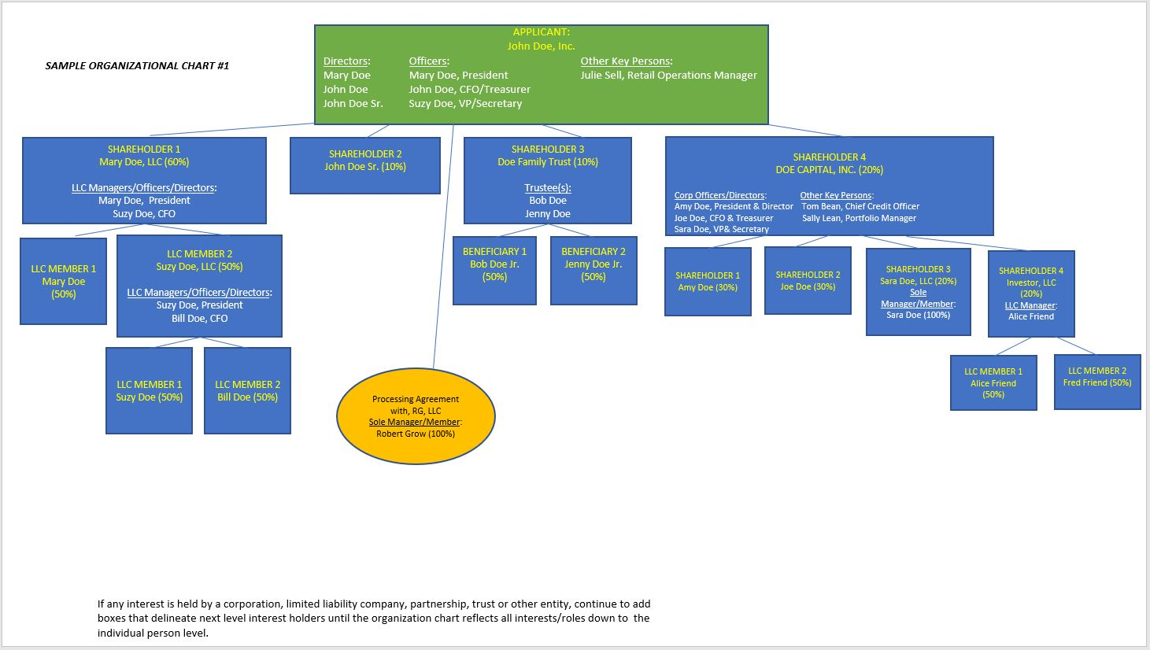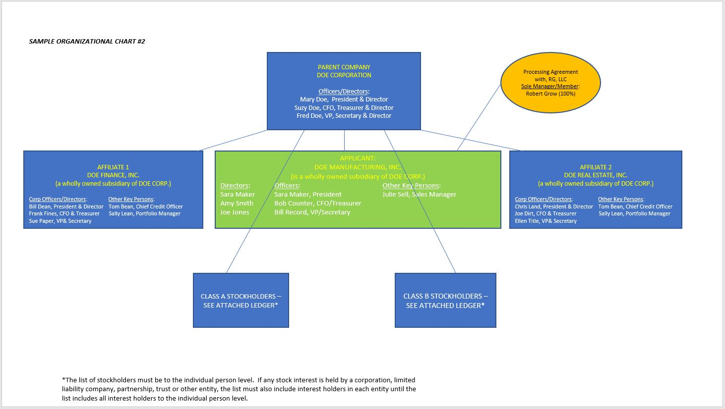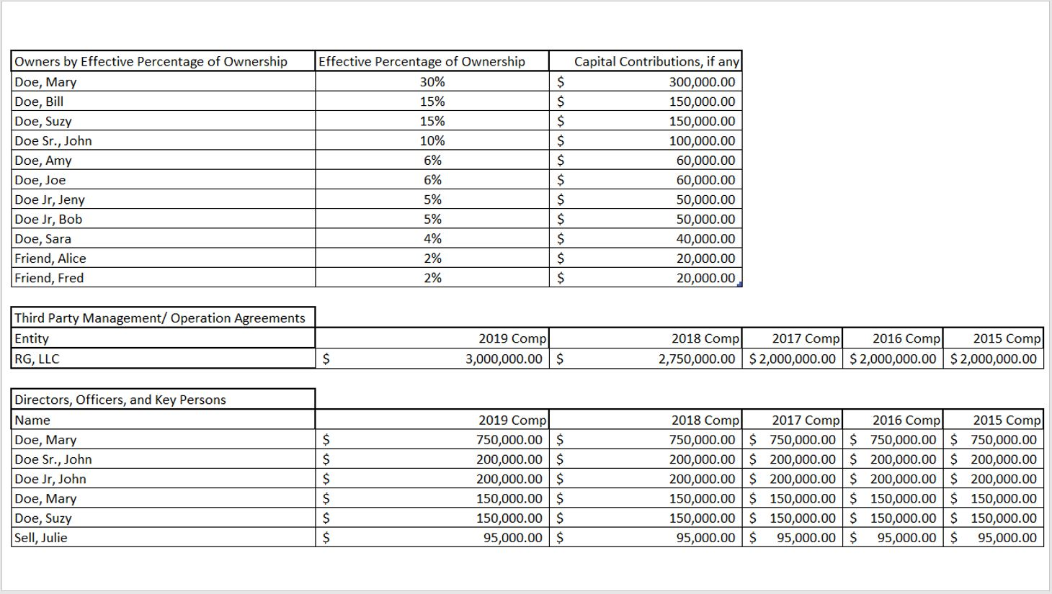

CERTIFICATION AS TO FORM 2
The undersigned duly authorized officer of the applicant/licensee, in his/her capacity as such officer and for and on behalf of the applicant/licensee, after due inquiry, hereby certifies to the Office of Cannabis Regulation of the Department of Business Regulation (the “Department” or “DBR”) that it/he/she has disclosed to the Department in this Form 2:
- With respect to the applicant/licensee, all persons and entities that:
(i) Are owners, members, officers, directors, managers or agents of the applicant/licensee, and/or
- Have/will have managing or operational control with respect to the applicant/licensee, its operations, the license and/or licensed facilities whether they have an ownership interest or not, and/or
(iii) Are investors or have any other financial interest therein, and/or
(iv) Hold interest(s) arising under shared management companies, management agreements, or other agreements that afford third-party management or operational control with respect to the applicant/licensee, its operations, the proposed license and/or the licensed facilities (any person or entity in the foregoing (i), (ii) and (iii) being herein individually referred to as an “interest holder” and all such persons and entities in the foregoing (i), (ii), (iii) and (iv) being collectively referred to as the “interest holders”), and
- To the extent that any interest holder described in (A) above is an entity, all interest holders in that entity until all such interest holders are identified and disclosed down to the individual person level.

The undersigned, after due inquiry, further certifies to the Department that, except for the license that is the subject of this Form 2 and except as permitted under R.I. Gen. Laws § 21-28.6-12(b)(10), no “interest holder” disclosed herein is an “interest holder” with respect to any other license issued by, or license application made to, the Department as to a “marijuana establishment licensee” as defined in R.I. Gen. Laws § 21-28.6-3(17).
The undersigned hereby acknowledges and agrees that the applicant/licensee has a continuing obligation to disclose any changes and shall provide written notice to the Department within thirty (30) days of any change of the persons/entities/interest holders described and the certifications made in this Form 2 and that each such notice shall include an updated Form 2.
Under penalty of perjury, I hereby declare and verify that all statements on and information submitted with this Form 2 are complete, true, correct and accurate.

Click here to enter a date.
Authorized Signatory Date

Printed Name
Printed Name
Print Name of Applicant/Licensee:
Print Officer Title:

FORM 3*

BUSINESS LICENSE IDENTIFICATION FORM
I/We, on behalf of the undersigned Licensee, hereby state(s) as follows:
With respect to the Licensee and the Interest Holders described in Form 2, Part I, such persons have either applied for or are currently or have been previously licensed or authorized to produce or otherwise deal in the manufacture or distribution of Marijuana in any form, in the following States or jurisdiction and corresponding agency or authority:
State & Name of Agency | Type of License | Name of Licensee | License or Registration #

I/we have disclosed and provided any and all denial, suspension, revocation or other sanction of the license or authorization listed above as instructed in FORM 5.
I/we hereby authorize the Rhode Island Department of Business Regulation to contact the state agencies indicated above for information regarding the Licensee and the licenses/registrations listed above and by our signature below, authorize such state agencies to provide any and all information requested by the Department regarding the licenses/registrations. If hereafter requested by the Department, I/we will provide any additional authorization required by any of the state agencies in order to provide information requested by the Department.

Click here to enter a date.
Name- Authorized Signatory Date

Name- Printed
Name- Printed

FORM 5*

Investors, Owners, Managers & Controlling Parties
Certification Statement Form
On behalf of the Licensee, and with respect to the Licensee and each of the Interest Holder described in Form 2, Part I, the undersigned certifies as follows:
1. None of the Licensee, any Interest Holder and any Marijuana business entity or its equivalent in which such persons hold or have held an interest, has had a registration or license, suspended, revoked, placed on probationary status or subject to any disciplinary action. If no, provide an explanation. | Yes  ☐ | No  ☐
4. Neither the Licensee or any Interest Holder is delinquent on the filing and/or payment of State or Federal taxes. If delinquent, provide an explanation. | Yes  ☐ | No  ☐
5. If the Licensee or any Interest Holder or any Marijuana business entity or its equivalent in which such persons hold or have held an interest holds or has held a medical Marijuana or medical marijuana license or registration in another State, have any such person(s) been disciplined (including, but not limited to restricted, suspended, or terminated) by any State? If yes, provide a brief explanation. | Yes  ☐ | No  ☐
6. None of the Licensee and any Interest Holder has been denied a professional license, privilege of taking an examination, or had a professional license or permit disciplined by a licensing authority in Rhode Island or other State. If no, provide a brief explanation. | Yes  ☐ | No  ☐
7. Is any Interest Holder employed by the State of Rhode Island? If no, skip next question. | Yes  ☐ | No  ☐
8. If any Interest Holder is employed by the State, please state the name, agency and position:

9. Does any Interest Holder have any “material financial interest or control” (as defined in Section 1.5(E)(5) of the Regulations) in another licensed cultivator, a compassion center, a licensed cooperative cultivation, or a Rhode Island DOH-approved third party testing provider or vice versa. If no, skip the next question. | Yes  ☐ | No  ☐
10. If any Interest Holder has such “material financial interest or control” or vice versa, please describe below.

11. Since the initial License date or the last renewal, whichever is the most recent, has the Licensee or any Interest Holder been convicted of or pled nolo contender to a crime other than a minor traffic violation?  If yes, provide a brief explanation. | Yes  ☐ | No  ☐
12. I acknowledge that I fully understand that:  Marijuana is a Schedule I controlled substance under the Controlled Substances Act of 1970 (21 U.S.C. 801 et seq.);  Manufacture, distribution, cultivation, processing, possession, or possession with intent to distribute a Schedule I controlled substance, or conspiring or attempting to do so, are offenses subject to harsh penalties under federal law and could result in arrest, prosecution, conviction, incarceration, fine, seizure of property, and loss of licenses or other privileges; and  Any activity regarding Marijuana that does not comply with Rhode Island law or regulations is a violation of State law and could result in arrest, prosecution, conviction, incarceration, fine, seizure of property, and loss of licenses or other privileges. | Yes  ☐  Yes  ☐  Yes  ☐ | No  ☐  No  ☐  No  ☐
Dated this __________day of ________________, 20______

____________________________________
Authorized Signatory
Printed Name:
Title:

Sworn to and subscribed before me on this ________day of ______________, 20________.

(SEAL) ___________________________________
Notary Public

FORM 6*
Mandatory Questions

Please describe any changes or updates to your business plan that affect scope of proposed activities (cultivation, manufacturing methods, products to be produced, packaging/labeling), budget and resource narratives and/ or, appropriate employee working conditions, benefits and training.
Click here to enter text.

Attach an updated diagram of the facility.
Attached: | ☐

Please recertify that the Licensee is eligible to do business in Rhode Island and, if applicable, attach any updated relevant documentation.
I certify the above is true: | ☐

Please re certify that the Licensee has filed all required tax returns and is not in arrears regarding any tax obligation in Rhode Island and other jurisdictions.
I certify the above is true: | ☐

If applicable, please provide an updated list of proposed medical Marijuana varieties and products proposed to be grown and/or manufactured. *
Click here to enter text.

Please certify that the Licensee has trained all employees and registered Cultivator agents on: | I certify:
- Federal and State Medical Marijuana laws and regulations, as well as other laws and regulations pertinent to the Cultivator agent’s responsibilities. | ☐
- Standard operating procedures. | ☐
- Detection and prevention of diversion of medical Marijuana. | ☐
- safety procedures, including responding to a (1) medical emergency, (2) a fire, and (3) a chemical spill. | ☐
- Safety procedures, including responding to threatening events including an armed robbery, an invasion, a burglary, and any other criminal incident. | ☐
If not, please explain below.
Click here to enter text.

Please certify that the Licensee has: | I certify:
- Secured the licensed premises and facility for cultivation of medical Marijuana to prevent unauthorized entry in accordance with the Regulations. | ☐
- Equipped the premises with adequate security lighting and a security alarm system that (1) covers the entire perimeter, as well as all perimeter entry points and portals at all premises (2) is continuously monitored, and (3) is capable of detecting smoke and fire, as well as power loss/interruption in accordance with the Regulations. | ☐
- Protected the premises by a video surveillance recording system to ensure surveillance of the entire perimeter of the area of cultivation, manufacturing and storage and adherence to the video surveillance requirements. As well as interior video surveillance that (1) records all activity in images of high quality and high resolution capable of clearly revealing facial detail, (2) operates 24-hours a day, 365 days a year without interruption, and (3) provides a date and time stamp for every recorded frame. The feed is remotely accessible to the Department of Business Regulation and is available to the Department and law enforcement in accordance with the Regulations. | ☐

If not, please explain below
Click here to enter text.

Please certify that: | I certify:
- when visitors are admitted to a non-public area of the licensed premises (1) Licensee logs the visitor in and out, (2) continuously visually supervises the visitor while on the premises, and (3) ensures that the visitor does not touch any plant or medical Marijuana. * | ☐
- maintains a log of all visitors | ☐

If not, please explain below.
Click here to enter text.

Please certify that the Licensee has: | I certify:
- established written standard operating procedures to promote good growing and handling practices including all aspects of the (1) irrigation, propagation, cultivation, and fertilization, (2) harvesting, drying, and curing, (3) processing or manufacturing, (4) packaging, labeling, and handling of medical Marijuana byproduct, and (5) waste products, and the control thereof, to promote good growing and handling practices. | ☐
- established written standard operating procedures to promote good growing and handling practices including requiring that each individual engaged in the cultivation, manufacturing, handling, and packaging, of medical Marijuana has the training, education, or experience necessary to perform assigned functions. | ☐
- established written standard operating procedures to promote good growing and handling practices including requiring that all registered Cultivator agents practice good hygiene and wear protective clothing as necessary to protect the products as well as themselves from exposure to potential contaminants. | ☐
- established written standard operating procedures to promote good growing and handling practices including requirements for receipt of material, including how the Licensee will inspect material for defects, contamination, and compliance with Regulations. | ☐
- established written standard operating procedures to promote good growing and maintain records of the type and amounts of, pesticides, fertilizer and any growth additives used. | ☐

If not, please explain below.
Click here to enter text.

Please certify that the Licensee has used and will continue to use pesticides in accordance with the Regulations and how the Licensee has established written standard operating procedures to ensure their safe use in accordance with regulation and other applicable state law.
I certify the above is true: | ☐
Attach an updated list of all pesticides used in the cultivation of medical marijuana.
Attached: | ☐

Please certify that the Licensee has sealed or screened the premises to exclude contaminants.
I certify the above is true: | ☐

Please certify that sanitation has been maintained through the facility in accordance with the Regulations.
I certify the above is true: | ☐

Please certify that the Licensee will notify the Department of Business Regulation of a meaningful discrepancy, if the Licensee discerns a discrepancy between the inventory of stock and inventory control outside of normal weight loss due to moisture loss and handling.
I certify the above is true: | ☐

Please certify that the Licensee has/will record(ed) and execute(ed) the transfer of medical marijuana to and/or from compassion centers in accordance with the Regulations.
I certify the above is true: | ☐

Please certify that the Licensee has/will not release(ed) any batch of medical Marijuana if the batch fails to meet all criteria for production or patient consumption in accordance with the Regulations.
I certify the above is true: | ☐

Please certify that the Licensee has/will ensure(ed) it does not transport medical marijuana to or receive(ed) any medical marijuana from any place outside of Rhode Island.
I certify the above is true: | ☐

THE QUESTIONS BELOW NEED ONLY BE COMPLETED BY LICENSEE’S WHOSE CULTIVATOR OPERATIONS INCLUDES MANUFACTURING, PROCESSING AND/OR PACKAGING (If not applicable, please note “N/A”)

Please certify that the Licensee has/will: | I certify:
- Require(ed) that any person involved in processing medical marijuana concentrates and medical marijuana-infused products is (1) appropriately trained in accordance to their job description to safely operate and maintain the system used for processing and attendance records are retained, (2) has direct access to applicable material safety sheets and labels, and (3) follows protocols for handling and storage of all chemicals. | ☐
- Establish(ed) a standard operating procedure for the methods, equipment, solvents, and gases when processing medical marijuana concentrates and medical marijuana-infused products. | ☐
- If the Licensee uses solvent extraction, the standard operating procedure of Licensee uses best practices to ensure worker and product safety; and follows all applicable federal, state, and local fire, safety, and building codes in the processing and storages of the solvents. | ☐

If not, please explain below.
Click here to enter text.

Please certify that: | I certify:
- the packaging and labeling of medical marijuana finished products has and will continue to be in compliance with all applicable Regulations. | ☐
- Licensee’s packaging of medical marijuana finished product has and will continue to bear any allergen warning required by law. | ☐
- Licensee’s packaging of medical marijuana finished product does not bear any resemblance to the trademarked, characteristic, or product-specialized packaging of any commercially available candy, snack, baked good, or beverage. | ☐
- Licensee’s packaging of medical marijuana finished product does not bear any statement, artwork, or design that could be reasonably mislead any person to believe that the package contains anything other than a medical marijuana finished product. | ☐
- Licensee’s packaging of medical marijuana finished product does not bear any cartoon, color scheme, image, graphic, or feature that might make the package attractive to children. | ☐

If not, please explain below.
Click here to enter text.

_ __ Click here to enter a date.
Authorized Signatory Date

Printed Name
Printed Name

